Amherst Victorian Dance Society
IMPORTANT DATES:
-Hotel Room Reduced Rate ($139) Hotel Registration Deadline is Sat. Oct. 28, 2023
See attached hotel registration info.
-Ball Registration Deadline is Sat. Oct 28, 2023

Twenty-Fourth Annual Victorian Ball
Saturday, November 11, 2023
The Honor of Your Company is requested for an evening of
1860’s Victorian Era Dancing at the
‘M’ Hotel Buffalo 2040 Walden Ave, Buffalo, NY 14225

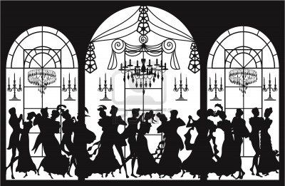
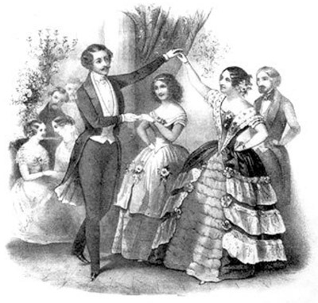
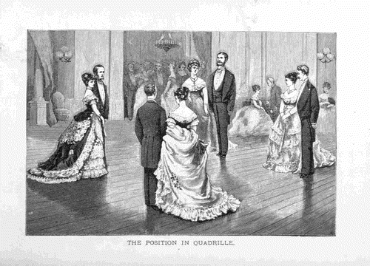

Social Hour with a Cash Bar at 6:00 PM
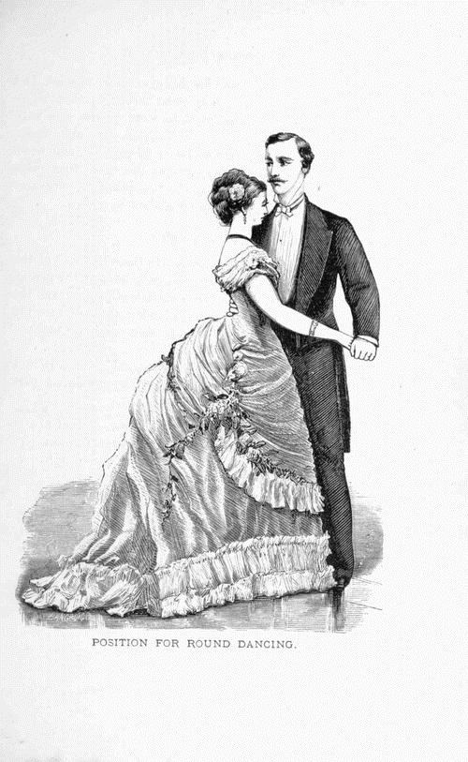
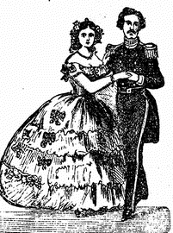
A sumptuous buffet dinner at 7:00 PM
Dancing from 8:00 – 11:00

Music by The Irish Volunteers Civil War Band
Guest Ball Dance Master will be Bob Nicholson of Syracuse, N.Y.

Learn or review dances to be done at the Ball at a workshop scheduled
from 11:00 am – 1:00 pm lead by Guest Dance Master Bob Nicholson
in the ‘M’ Hotel Buffalo Ballroom the morning of the Ball. (Optional)

The price of the Ball, including the buffet dinner and workshop is $65.00 per person.

Make Ball reservations by completing and mailing the enclosed forms to:
Fran Arcuri
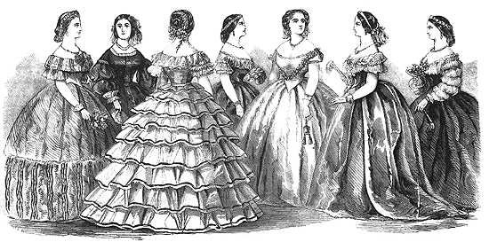
Check out our Society Website: www.amherstvictoriandance.org

2195 Maple Road
Williamsville, N.Y. 14221
Direct any questions to Fran Arcuri at 716-812-6991 or fran_arcuri@yahoo.com
Attire::
Ladies- Victorian Ball gowns or cocktail dresses
Gents - Victorian formal wear, Civil War vintage military uniforms or Suit & tie.
HOTEL ROOM RESERVATIONS MUST BE MADE DIRECTLY WITH ‘M’ Hotel Buffalo 716-681-2400. See attached Hotel reservation information page.

