Amherst Victorian Dance Society
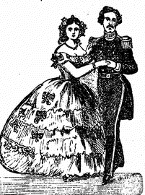
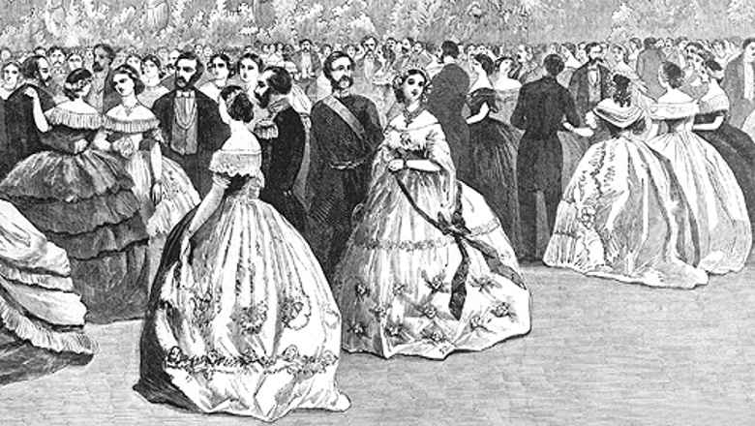
Twenty-Fourth Annual Victorian Ball
Registration Form

- To make Reservations for the Ball, please fill out the Ball Registration Form below and the separate Table Reservation Form. Also see sheet of information on accessing reduced hotel rates.

- Include a check for the Ball @ $65.00 /person payable to Amherst Victorian Dance Society

3. Mail Forms & Check to: Fran Arcuri
2195 Maple Road
Williamsville, N.Y. 14221

Any questions, contact Fran Arcuri at (716) –812-6991or fran_arcuri@yahoo.com
**** Ball Reservations accepted no later than Saturday, Oct. 28, 2023 ****
____________________________________________________________________

PLEASE INCLUDE ALL CONTACT INFORMATION TO HELP WITH 2023 BALL PLANNING AND DEVELOPMENT OF ACCURATE MAILING / ELECTRONIC INFO. FOR FUTURE EVENTS.

Name _____________________________________________ Attending Workshop ? yes ___ no____
Address____________________________________________
E-Mail: ______________________________________________ Telephone_________________________

Name _____________________________________________ Attending Workshop ? yes ___ no____
Address____________________________________________
E-Mail: ______________________________________________ Telephone_________________________

Name _____________________________________________ Attending Workshop ? yes ___ no____
Address____________________________________________
E-Mail: ______________________________________________ Telephone_________________________

Name _____________________________________________ Attending Workshop ? yes ___ no____
Address____________________________________________
E-Mail: ______________________________________________ Telephone_________________________
Number attending________@ $65.00 each Total Enclosed $_______________
Make checks payable to: Amherst Victorian Dance Society….Cancelled check will be your confirmation.

