24th Annual Victorian Ball

“A Step Back In Time” ( 1860’s Era )

Sponsored by: Amherst Victorian Dance Society

November 11th, 2023

Venue: ‘M’ Hotel Buffalo Ballroom – Workshop & Ball

*Rooms available at $139.00/nite

Band: The Irish Volunteers Civil War Band

Dance Master: Bob Nicholson of Syracuse, NY

Open to the Public

Schedule of Events:

11:00 am-1:00 pm Workshop to learn dances for the Ball (optional)

6:00-7:00 pm Social Hour

7:00-8:00 pm Sumptuous Buffet Dinner

8:00-11:00 – Grand Ball

Auction:

2x East Lake Chairs

The Eastlake movement is from 1870 to1890. The wood is black walnut. The wheels are ceramic.

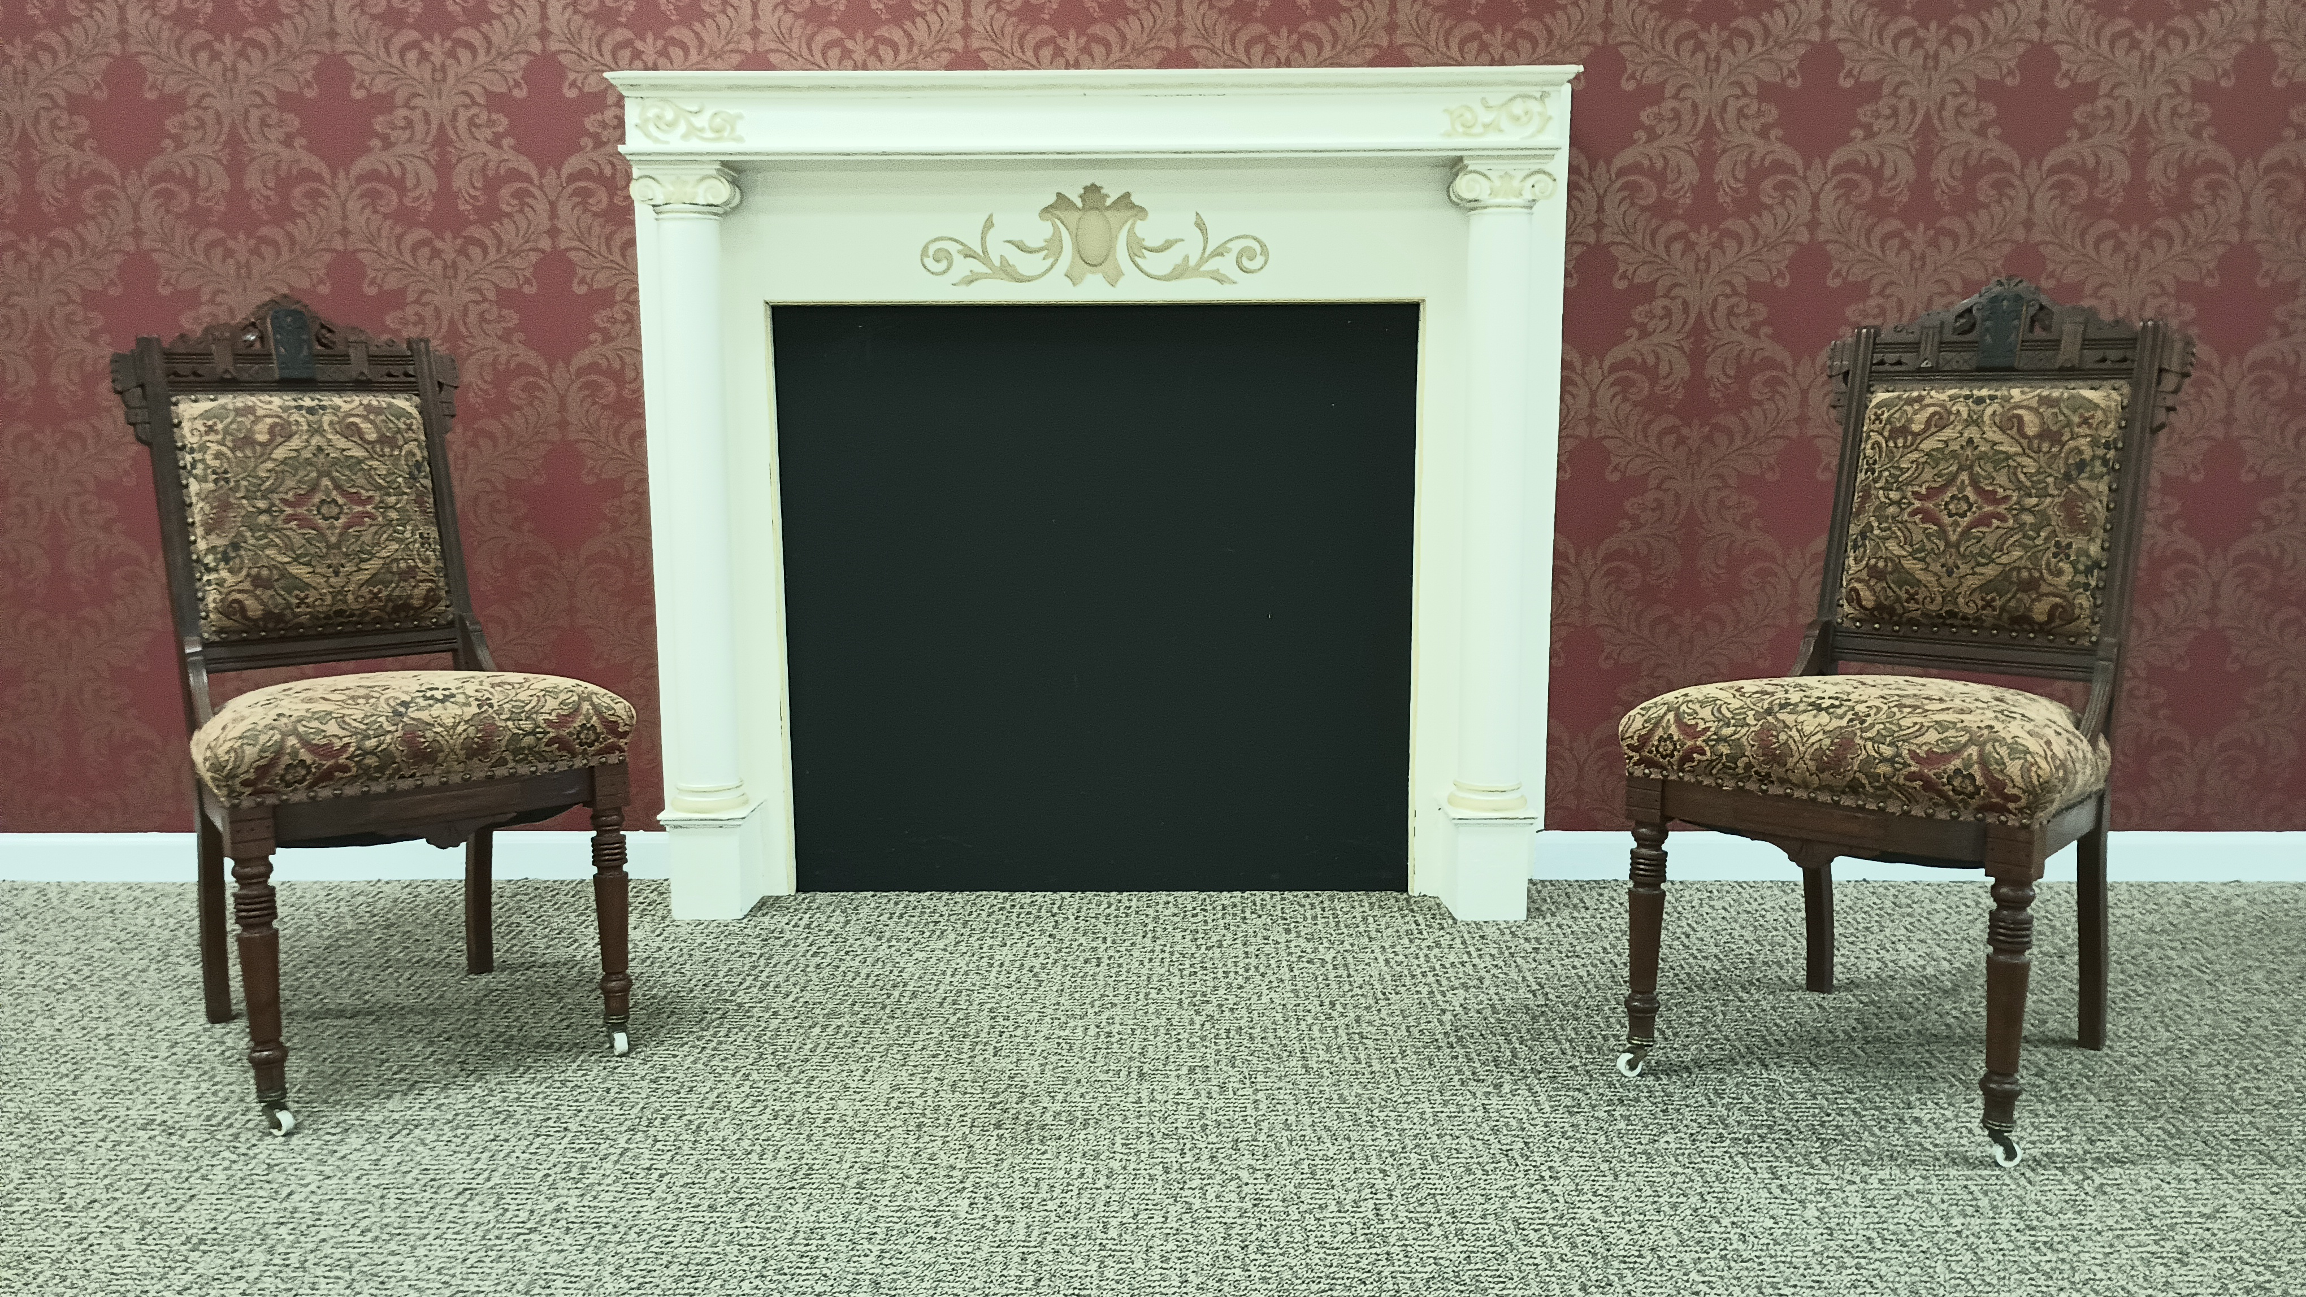

Reservations / Information: Fran at 716-812-6991

Attire: Ladies – Victorian Ball Gowns or Cocktail Dresses

Gents -- Victorian Formal Wear, Civil War Uniforms or Suit & Tie

Admission: $65.00 /person – Includes AM Workshop, Dinner & Ball

Visit [www.amherstvictoriandance.org](http://www.amherstvictoriandance.org) to learn more about Victorian Dance.