Table Reservation Form
Tear off & return this form with Ball Registration Forms
Tables for 8 may be reserved in advance for friends and family when the Reservation Form below has been filled out and mailed with the Ball Reservation Form.
1. To complete the table reservation form for your group, please communicate with each other.
2. Send only one form for a group.
3. Table Reservation Form must be received by Saturday, October 28, 2023
4. All tables will be assigned in order received. Every effort will be made to honor requests.
5. Tables seat eight (8).
6. No changes in table groupings will made the night of the Ball.
1. ___________________________________ 6. _________________________________

2. ___________________________________ 7. _________________________________

3. ___________________________________ 8. _________________________________
Glove Wearing, a Victorian “Thing” !
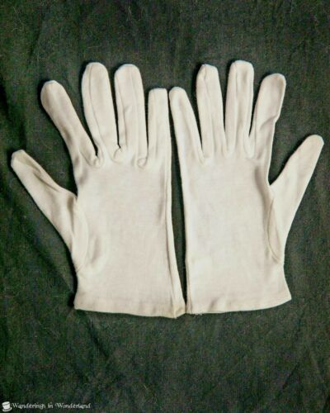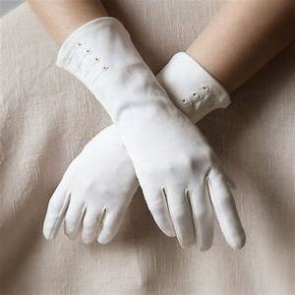
4. ___________________________________

5.____________________________________

Name & Telephone Number of person making this request: ______________________________________________

======================================================================================
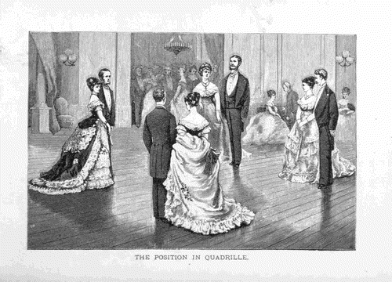
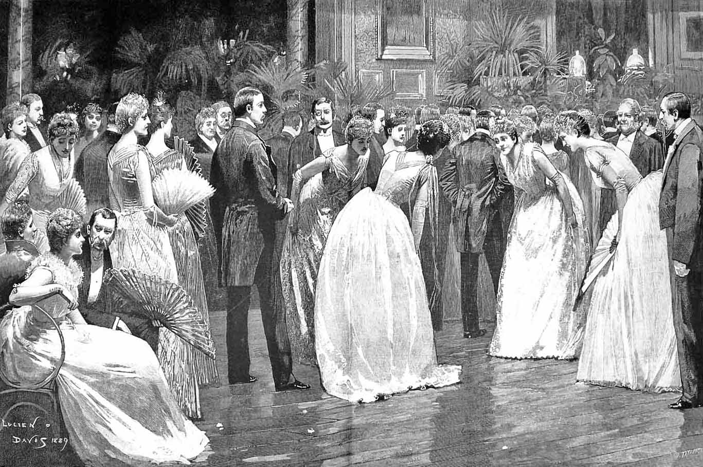
Hotel Reservations
‘M’ Hotel - Buffalo
A block of rooms has been reserved at the ‘M’ Hotel Buffalo for Friday 11/10/23 and Saturday 11/11/23 at a reduced rate o$139.00 per night plus tax. 2040 Walden Ave, Buffalo, NY 14225
Guests will call the hotel directly to make reservations (1-716- 681-2400 ) Ask for the AMHERST VICTORIAN DANCE SOCIETY room rate of $139.00 /nite.
Reduced rate reservations may be made up until Saturday, OCTOBER 28, 2023.
- Rooms are double Queen beds
- Reduced rates are honored up to and including Oct. 28th, 2023.
- Check-in time: 4:00 pm. Check-out time: 11:00 am.
- Free complimentary outside parking.
- Complimentary wireless internet in guestrooms and public spaces.
- Hotel Room Cancellation Policy: Deposit refunds are if canceled 24 hours ahead of reservation.

