Social Dances of the Nineteenth Century
Richard Powers
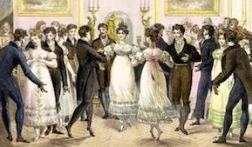
Following the fall of the Ancien Regime in 1789, social dancing became more natural and egalitarian. Both clothing and dancing became less elaborate and restrictive as the rigid formalities of the Baroque ballroom eased.
19th century social dance can be seen as three eras, each with its unique clothing, manners, music and dances:
The Regency Era This term, referring to the English Prince Regent (1811-1820), is sometimes used informally to refer to the wider period between 1800 and the 1830s. In England and France, the most popular new dance of 1815 was the Quadrille, created from older French Contradanse and Cotillon figures. The Quadrille was performed with a wide variety of rapid, skimming steps, such as the chassé, jeté assemblé and entrechats. English Country Dances, the Scotch Reel and Mazurka also featured intricate steps, and added variety to an evening's dancing. These set dances, done in formations of squares and lines, were joined by an unusual novelty performed by individual couples: the Waltz, which had risen from peasant origins to society assembly rooms. However the Waltz was more often discussed than actually danced at first. After centuries of dancing at arm's length from one's partner, much of genteel society was not ready to accept the closed embrace of the Waltz.
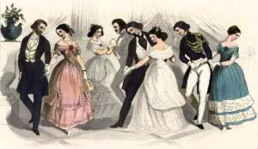
The flowering of the Romantic Era While the Waltz received a great deal of criticism, as "leading to the most licentious of consequences," it slowly made some inroads into the ballroom, aided by the occasional performance by a notable society figure. Waltzing jumped ahead in acceptability when its inherent sensuousness was tempered with a playful exuberance, first by the Galop and then by the Polka. The Polka from Bohemia became an overnight sensation in society ballrooms in 1844, eclipsing the Waltz at the time. The Polka's good-natured quality of wholesome joy finally made closed-couple turning acceptable, introducing thousands of dancers to the pleasure of spinning in the arms of another. Once they tasted this euphoria, dancers quickly developed an appetite for more. The Polka mania led to a flowering of other couple dances, including the Schottische, Valse à Deux Temps, Redowa, Five-Step Waltz and Varsouvienne, plus new variations on the earlier Waltz, Mazurka and Galop. Meanwhile, the increasing trend toward ease and naturalness in dancing had eliminated the intricate steps from the Quadrille and country dances, reducing their performance to simple walking.
The overall spirit of this era's dancing (1840s-1860s) was one of excitement, exuberance and gracious romance. The dances were fresh, inventive, youthful and somewhat daring. Society fashions were rich and elegant, but continued an emphasis on simplicity. By the 1850s, the ballroom had reached its zenith.
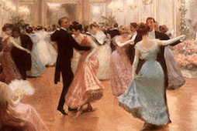
The High Victorian Era By 1870, social dances were now those of one's parents, or even grandparents. The ballroom was slowly becoming the domain of high society's Old Guard. As dancing become less exciting, fewer people devoted themselves to mastering the full repertoire of dances. One-by-one, the Mazurka, Schottische, Redowa and Polka began to fade. Dance masters formed professional associations in an attempt to save their trade, but these organizations mostly resulted in the standardization and codification of dance steps, which further dampened the public's enthusiasm. Dance masters invented dozens of new steps in an attempt to revive interest, but the public remained largely indifferent. High society balls shifted their emphasis to the "German" parlor cotillion games, featuring expensive favors (prizes). Middle class public balls saw the great variety of dances dwindle to just two: the Waltz and Two-Step. By the end of the century, dancers were ready for something completely different. After centuries of innovations created by European leaders of society, they would not have guessed that the next wave of popular dance and music would come from America's lower classes.

